1 Walkthrough 32 Routing with Parameters

[https://sapui5.hana.ondemand.com/#/topic/2366345a94f64ec1a80f9d9ce50a59ef](https://sapui5.hana.ondemand.com/#/topic/2366345a94f64ec1a80f9d9ce50a59ef#)

2 Core Changed Codes Compared to Last Version:

2.1 manifest.json 增加跳转参数

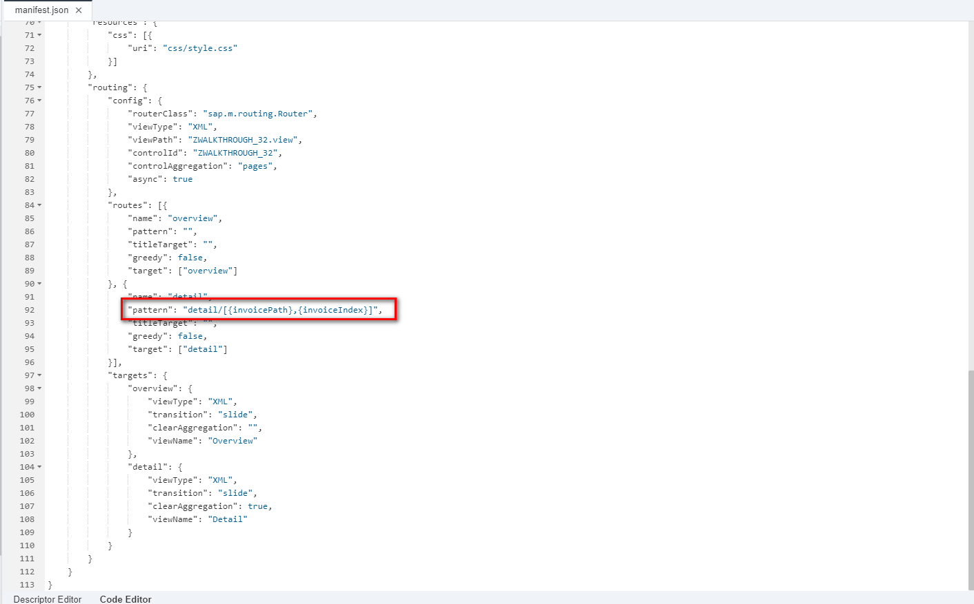

2.2 InvoiceList.controller.js 处理跳转参数

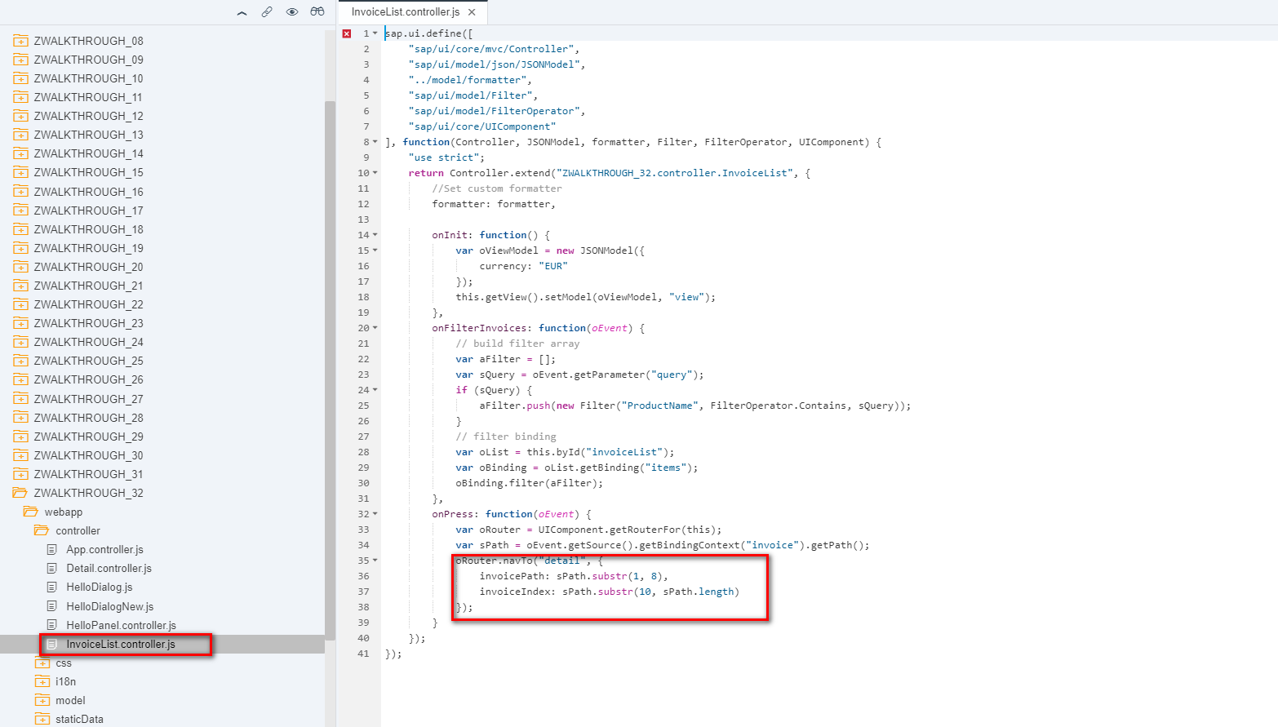

2.3 Detail.controller.js 明细界面控制器,处理跳转行为

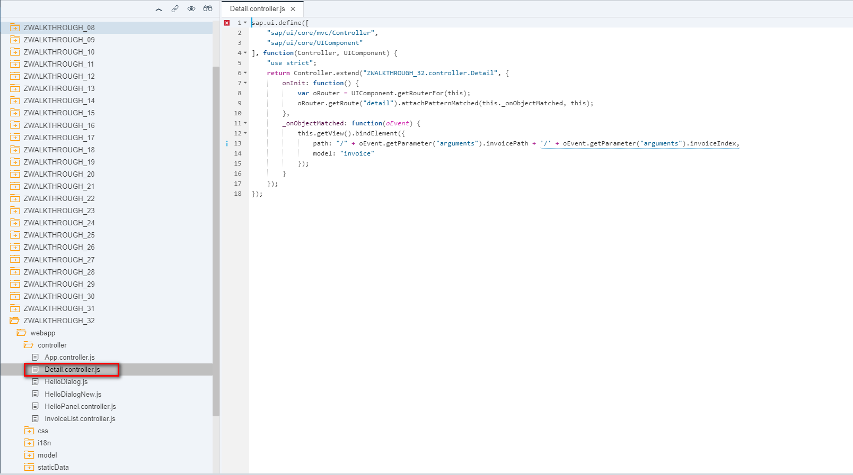

2.4 Detail.view.xml 增加跳转参数携带属性

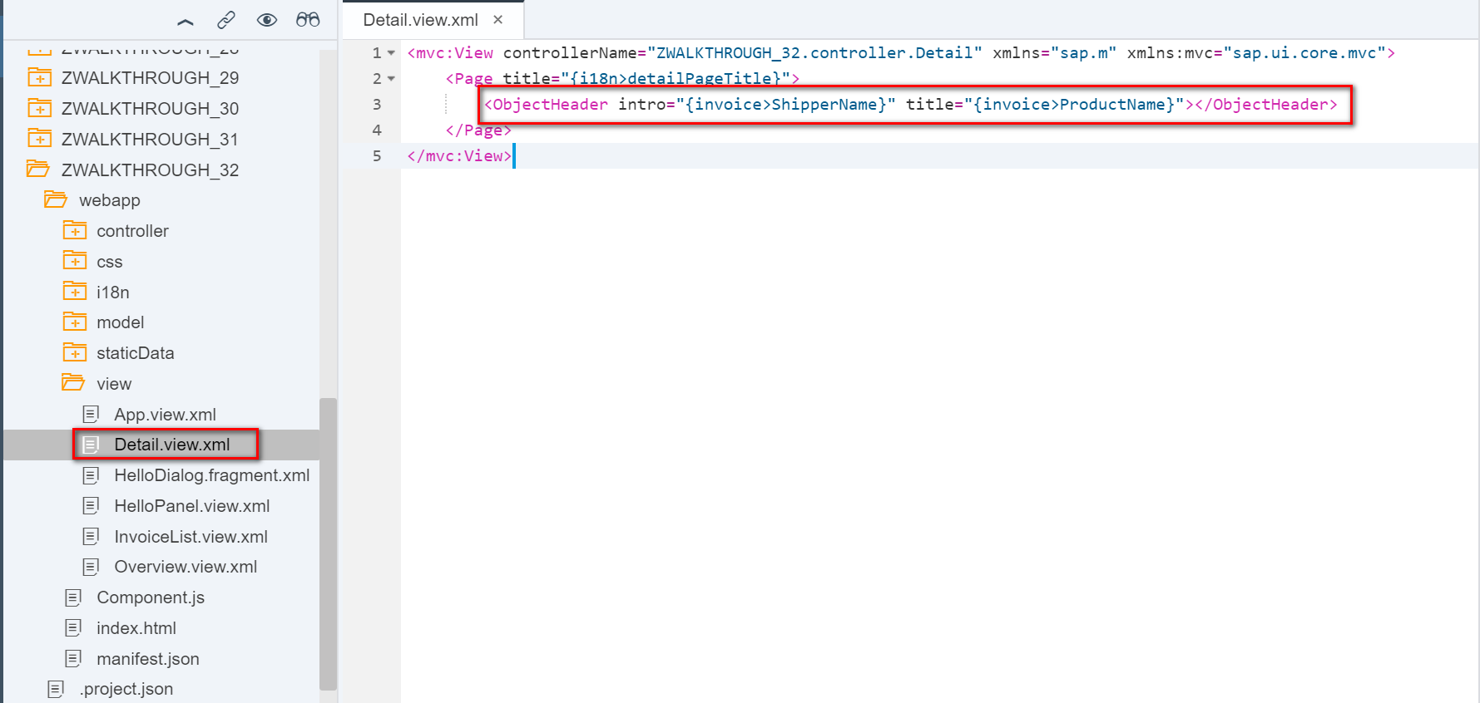

3 i18n 文本对象管理

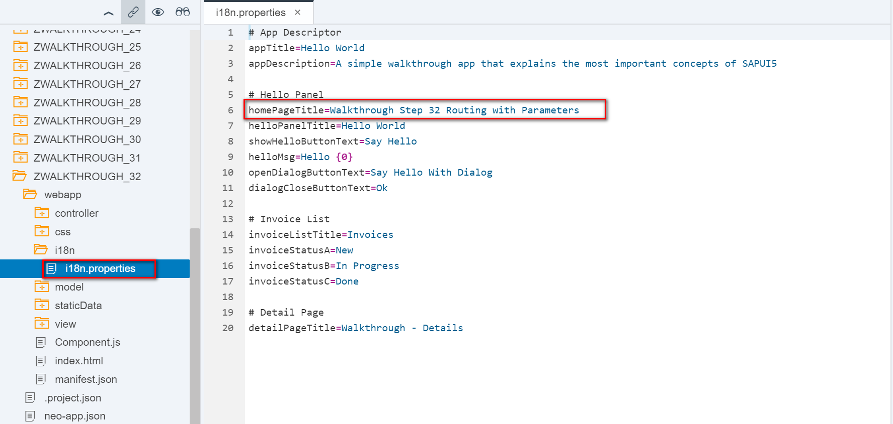

4 Result



5 Git:

https://github.com/xiexiaop/SAPUI5-2-Round/tree/master/Projects/ZWALKTHROUGH_32

2019/02/08 XiaoMi Beijing Zac,Xie